HONITON AND DISTRICT AGRICULTURAL ASSOCIATION

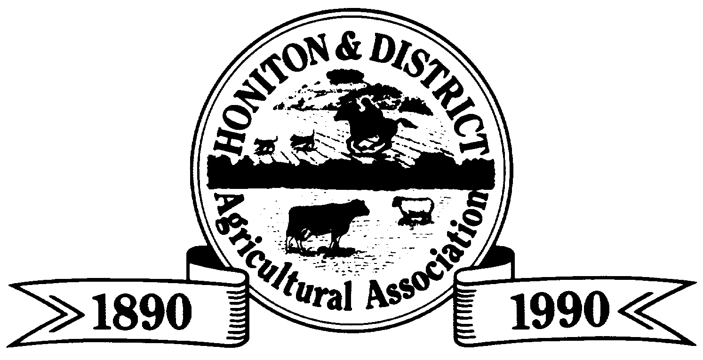

FARMS COMPETITIONS
The Farm Competitions are run throughout the year ranging from Farm Management to Silage Classes. The aim of the classes is to run in conjunction with the Show and in turn keep a year long interest in the Honiton & District Agricultural Association. The entry fee per class is £3.00 and listed below are the dates and contacts for each individual section.

Notify Interest | Judging | Class Description | Contact Steward
April | End of April/May | Grass Leys 1-2 Yr  3 Yr + | Office 01404 41794
Beg June | June | Cereals
 |  | Winter Wheat | Office  01404 41794
 |  | Winter/Spring Barley | George Alder  07970 089532
Beg June | June/July | Dairy Herds  Large Herd  Small Herd | Office  01404 41794
Beg June | July | Potatoes | Office 01404 41794
 | 5th & 6th August | Honiton Show | Office 01404 41794
Beg Aug | September | Beef Classes  Suckler Herd  Commercial Herd | Office 01404 41794
Mid Aug | September | Sheep
 |  | Commercial Large & Small | Pauline Hopkins  01404 831330
 |  | Pedigree Large & Small | Henry Derryman  01404 881296
Mid Aug | September | Field Maize | Donald Arscott  01823 601278
Beg Nov | January | Silage  Grass Clamp  Maize Clamp  Big Bale | Ben Trott  01297 32633

The Victor Ludorum is won for the most points gained in the above classes and the classes are open to any farmer who resides in the Honiton & District Agricultural Association Local Boundary – definition enclosed. If you would like to enter these classes please contact your listed steward or the Farms Competitions administrator on 01404 41794 – Many thanks.

