HONITON & DISTRICT
AGRICULTURAL ASSOCIATION
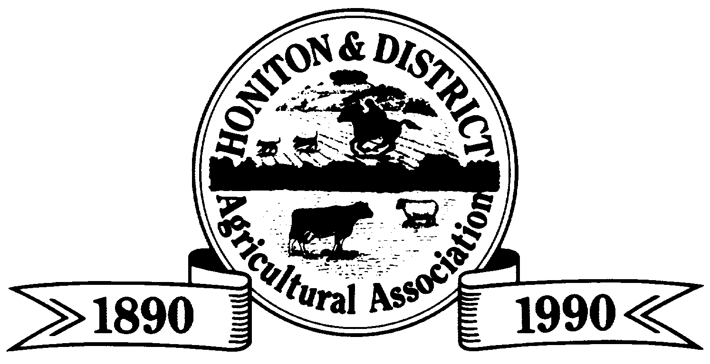

FREE FUN DOG SHOW
Kindly sponsored by
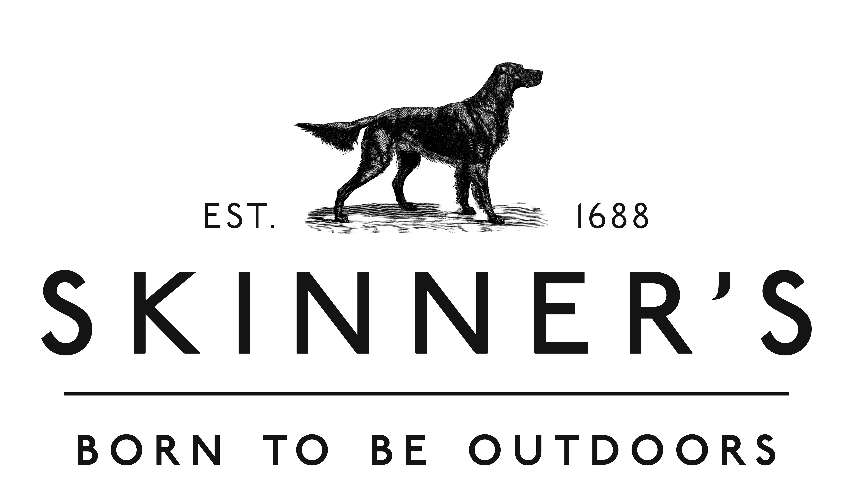

THURSDAY 3rd AUGUST 2023
HONITON SHOW GROUND (Adjacent to the A30 Honiton)
Admission to Show Adults £20.00 In Advance £17.50
Children Free (when accompanied by a paying adult)
ADMISSION TICKETS MAY BE PURCHASED IN ADVANCE VIA
WWW.HONITONSHOW.CO.UK
Only Pay to enter the show then enter as many classes and dogs as you like

JUDGE: Debra Revell “Haromsag”

Pedigree Classes (to start at 10.00am)
Rosettes/Prize Cards 1st- 6th
- Any Variety Puppy 6-12 months
- Any Variety Toy and Terrier
- Any Variety Working and Pastoral
- Any Variety Hound and Utility
- Any Variety Gun Dog
- Any Variety Veteran – Over 7 years
Best Pedigree in show will now be judged
Classes 1-6 no challenge certificate winners/res challenge certificate
Winners or junior warrant to enter classes
7. Child Handling up to 10 yrs
8. Child Handling 11-16 yrs
Best Child Handler will now be judged – Rosettes/Prize Cards 1st – 6th
Please make sure your child can handle the size of dog he/she is handling
9. Adult Handling Over 16 yrs
Novelty Classes (to start at 2.00pm)
Rosettes/Prize Cards 1st - 6th
10. Best Cross Breed Dog or Bitch
11. Best Non Pedigree Puppy Dog or Bitch
12. Best Non Pedigree Veteran (Rosette for the oldest dog) Dog/ Bitch Over 7 Years
13. Prettiest Bitch
14. Handsome Dog
15. Waggiest Tail Dog or Bitch
16. Best Mover Dog or Bitch
17. Best Rescue Dog or Bitch
18. Best Trick Dog or Bitch
19. The Dog or Bitch the Judge would most like to take home
20. Best Sausage Catcher Dog of Bitch
Best In Show – from Classes 10-20
Any Dogs (over 6 months of age) Can Enter Classes 10-20

The Show cannot be held responsible for any accidental damage or loss to persons, animals and personal belongings. Please clean up after your dog.

